The Art Union Journal 1846 Volume 8
In 1846 William Henry Fox Talbot provided probably over 6000 original Talbotype images to the Art Union journal in a promotional effort which today is largely overlooked. The images were provided to popularise his photographic method and the publication was the first journal in the world to include photographs. Due largely to the haste of production, today, the images are often badly faded and this has contributed to the poor reputation of the feat. I think however, that these unique images from the birth of photography deserve to be better understood.

The Project
Some years ago when I first came across one of these images it set me wondering about all the rest that might still be in existence…. This project is aimed at answering some of these questions both for my own satisfaction, and to provide a better understanding of Talbots work for others who may also be interested in the future.
Where are these images now?, how many have survived and what was the lasting legacy of the stunt? These are some of questions that will be explored by the 1846 Art Union project. Although I’m just a private researcher with an interest in the history of photography, I’m pleased to have received encouragement to undertake this project by more recognised authorities. I’m hopeful that the current keepers of the volumes will also have an interest in supporting the project. You can find out about me and another of my photo history projects at www.onahillroad.com

Your Help is appreciated.
If you are the keeper of one or more copies of Volume 8 of the Art Union Journal or have a photograph that has been removed from a copy, your help would really be appreciated with this project. As a first step I am trying to locate and document as many copies as I can. For each copy I would like to ascertain some basic details about it. Some of these details will always be kept private (see request form), some may later be published a part of the reference information about volumes that have survived. It would be great if you could provide as much of the detail requested below as possible and please do attach a digital photograph (recommended) or a scan (if you are happy with this process) of your image. Please note these details will be collated on a computer database.

Your Volume Reference
For each copy that I identify I will be allocating a unique copy reference number, I will send this to you and I would be pleased if the reference could be kept associated with the copy as I hope it may benefit future researchers and avoid double counting.

Your Feed back
If you would like to receive feedback on the project (not more than twice per year) please do indicate that you would be happy to receive email updates.

Where to send your details
Please send your submission to updates@1846ArtUnion.org

The Art Union Journal 1846 Volume 8

About the Keeper of the Copy(s):
The keeper is the person who may be contacted about the project eg. A curator or private holder
Organisation (if applicable)

Keeper Contact:
Mr/Mrs
Keeper Contact:
First Name
Keeper Contact:
Last Name
Keeper Contact:
Position
Keeper Contact:
Telephone Number
Keeper Contact:
Email Address
Keeper Contact:  Email Preference | Please DO / DO NOT send me project update emails  Delete as appropriate
Keeper Address
Keeper Country
Keeper Organisation Website
Keeper Privacy Preference | If you would prefer that these Keeper details are kept private please indicate here – delete as appropriate | The keeper contact  MAY / MAY NOT be disclosed.  Delete as appropriate
Any Other Keeper Comments you wish to provide
Please note these details will be collated on a computer database. I will normally treat the name of an organisational keeper (eg. a Library) as public information even if the keeper contact is to remain private. If you do not wish this to be the case please add a comment to this effect.

The Art Union Journal 1846 Volume 8

IMAGE INFORMATION About this copy:
Please complete this section for each copy of the journal/image held.
This information may be made public (even if the keeper is anonymous).
Your own Library Reference To Volume /image (if any)
What is the subject of the photograph?
Have you provided a digital image(s)? | YES/NO  Delete as appropriate
Dimensions of the photograph in mm | mm High | mm Wide
SCHAAF No of Talbot image if known?
Which patent label appears on the back of the page? | Please see reference page.  A– Patent Talbotype or Sun Pictures  B – Patent Talbotype (Brookes)  C- something else  (please provide full wording details and a digital image if possible)
Is the image still in an Art Union Journal copy? | YES In Art Union Journal / NO image is separated  Delete as appropriate
Please comment on the condition of the photograph and the journal volume.
How is the volume currently stored?
Temp controls etc if any.
Can you provide any details of the volumes providence? How and when was it acquired?
Thank You for your help with the 1846 Art Union Photographs Project

Reverse Patent Labels
A Patent Talbotype or Sun Pictures
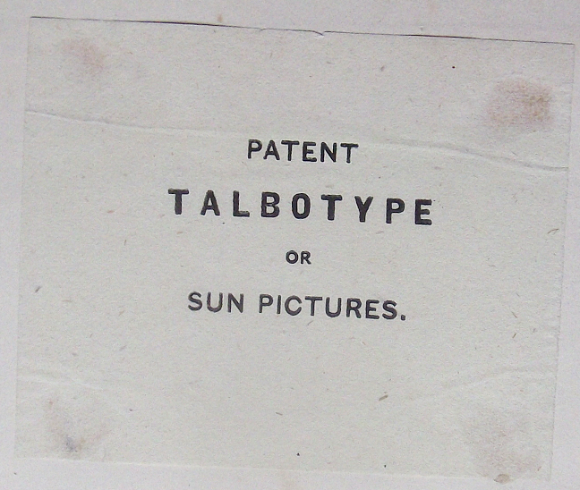
B Patent Talbotype (Brookes) 